Thank you all for spending **so much time** on that meeting last week!

Whatever happens, I have confidence that this group will make decisions with the best interest of our community in mind.

I do want to bring up a concern I have that I didn't feel comfortable sharing during the meeting. I do think that we should have higher standards for social distancing and measures to prevent spreading of COVID. Note the two men well within 6 feet of each other while indoors and not wearing masks:

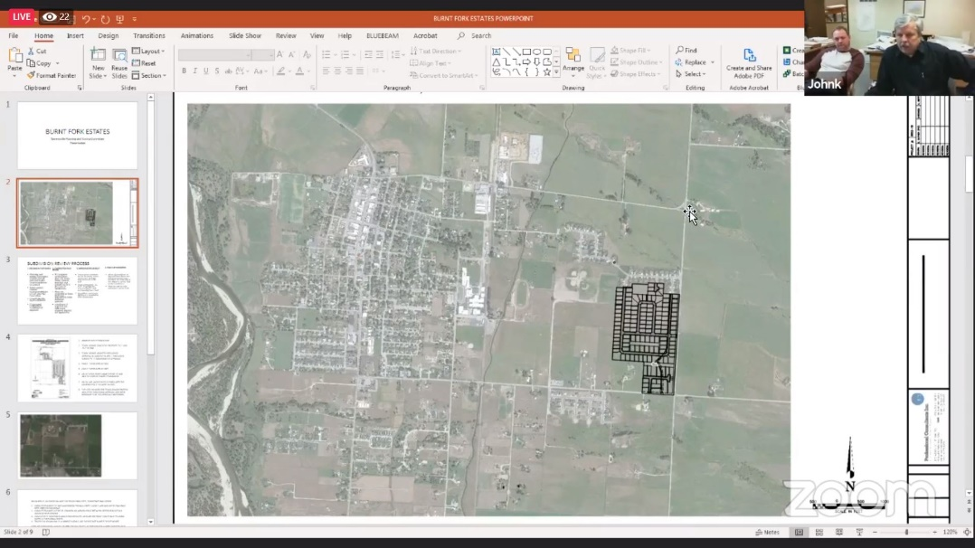

I think we should require participants in community events to abide by health department and CDC recommendations for safety.

My 2c.

Thanks again!

Gabe