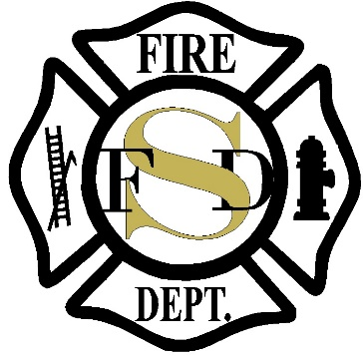

Adminsitrative ASSISTANT

Supplemental Essay Questions

In order to get a better sense of your writing skills and additional insights into your experience, please answer the following questions. Limit your responses to no more than a single page per question and submit your answers as part of your application.

1. What have you learned about the Town of Stevensville/Stevensville Fire Department that makes you interested in this position, and why is now a good time in your career to consider applying for this position?

- What does delivering a public service mean to you?

- Please give a brief description of your ideal work environment.

